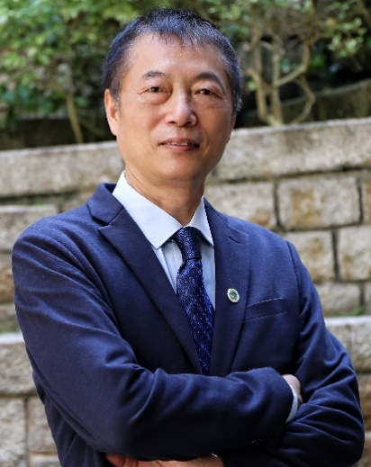
Professor Wanlei Zhou
Vice Rector (Academic Affairs)
Dean of the Faculty of Data Science
City University of Macau
Email: wlzhou@cityu.edu.mo
URL: https://cityu.edu.mo/en/about-cityu-2/university-structure-2/vice-rector/
ORCID: https://orcid.org/0000-0002-1680-2521
Google Scholar: https://scholar.google.com.au/citations?user=ogO059YAAAAJ&hl=en
DBLP: https://dblp.org/pid/92/2939.html

Short Bio:
Professor Wanlei Zhou is currently the Vice Rector (Academic Affairs) and Dean of the Faculty of Data Science, City University of Macau, Macao SAR, China. He received the B.Eng and M.Eng degrees from Harbin Institute of Technology, Harbin, China in 1982 and 1984, respectively, and the PhD degree from The Australian National University, Canberra, Australia, in 1991, all in Computer Science and Engineering. He also received a DSc degree (a higher Doctorate degree) from Deakin University in 2002. Before joining City University of Macau, Professor Zhou held various positions including the Head of School of Computer Science at the University of Technology Sydney, Australia, the Alfred Deakin Professor, Chair of Information Technology, Associate Dean, and Head of School of Information Technology in Deakin University, Australia. Professor Zhou also served as a lecturer at the University of Electronic Science and Technology of China, a system programmer in HP at Massachusetts, USA; a lecturer in Monash University, Melbourne, Australia; and a lecturer in National University of Singapore, Singapore. His main research interests include security, privacy, and distributed computing. Professor Zhou has published more than 500 papers in refereed international journals and refereed international conference proceedings, including many articles in IEEE transactions and journals. Professor Zhou is an IEEE Fellow and a Life Member of the IEEE.

