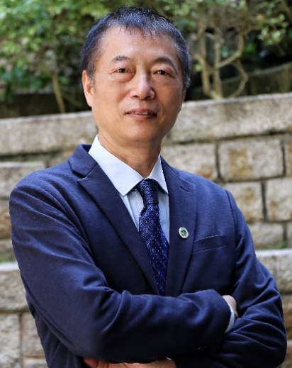
Professor Wanlei Zhou
Vice Rector (Academic Affairs)
Dean of the Faculty of Data Science
City University of Macau

Title 1: Machine Unlearning: A New Requirement of the AI Era
Abstract:
Over the past decade, machine learning has experienced remarkable advancements, positively impacting our daily lives. Alongside this progress, a distinctive requirement has emerged—stemming from the AI era, in particular, from privacy concerns, usability considerations, and “the right to be forgotten”—leading to the development of a new concept known as machine unlearning. In this lecture, I will undertake a comprehensive exploration of machine unlearning. First, I will give the reasons behind the existence of this necessity. Second, I will talk about recent developments in this field. And then, I will introduce some corresponding solutions for unlearning, especially some of the recent work from my research group in machine unlearning.

