Tiago H. Falk

Biographical sketch and photo:
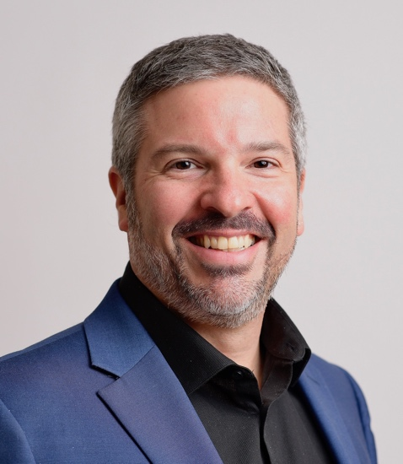
Tiago H. Falk is a Full Professor at INRS-EMT, University of Québec, where he directs the Multisensory Signal Analysis and Enhancement Lab. He is also co-director of the INRS-UQO Joint Research Unit on Cybersecurity and Digital Trust. His research interests are in the development of secure human-machine interfaces (HMIs) for both real and multisensory virtual environments using signal processing and machine learning tools. He is co-chair of the IEEE Telepresence Initiative, co-chair of the IEEE Systems, Man, and Cybernetics (SMC) Technical Committee on Brain-Machine Interface Systems, a Steering Committee member of the IEEE BRAIN Technical Community 2.0, the IEEE SPS Autonomous Systems Initiative, and the IEEE SPS Data Science Initiative. He is a Fellow of the IEEE and a Member-at-Large of the IEEE SMC Society Board of Governors. He has over 400 publications in the broad domain of HMIs, with over 11,300+ citations (h-index=51). He has given 60 invited/guest/keynote speeches in the last decade.

