2020 IEEE SMC Society Awards Ceremony

Oct 13, 2020

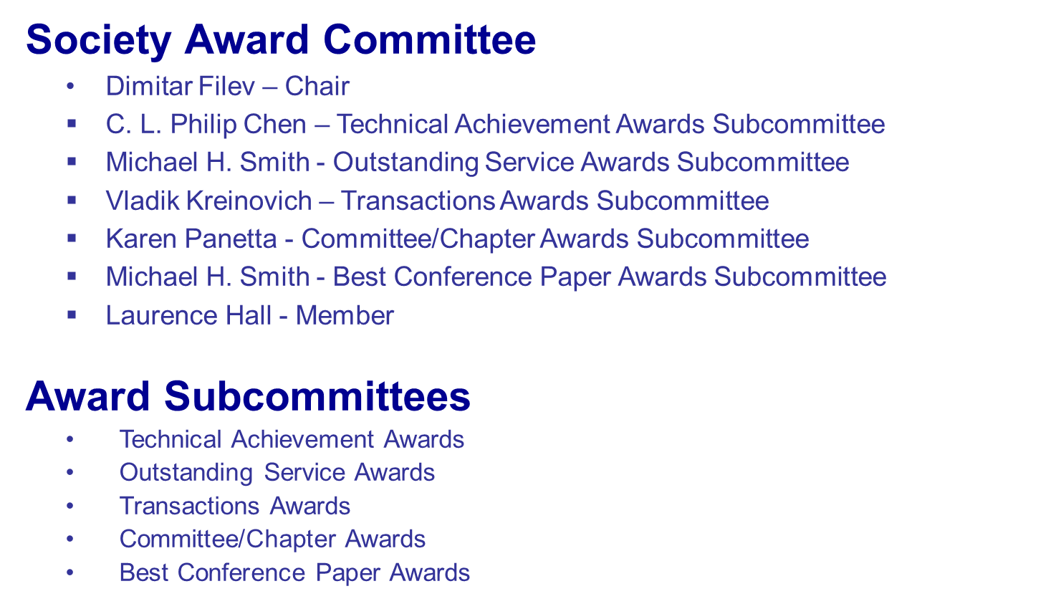
2020 IEEE SMC Society Awards
- Lotfi A. Zadeh Pioneer Award
- Norbert Wiener Outstanding Research Award
- Joseph G. Wohl Outstanding Career Award
- Outstanding Contribution Award
- Early Career Award
- Meritorious Service Award
- Outstanding Service to Humanity Award
- Andrew P. Sage Best Transactions Paper Award
- IEEE SMC Best Associate Editor Award
- IEEE Most Active SMC Technical Committee Award
- IEEE Outstanding SMC Chapter Award
- IEEE Outstanding SMC Student Branch Chapter Award
- Franklin V. Taylor Memorial Award (best annual conference paper)
- Outstanding SMC Student Paper Award
IEEE Systems, Man, and Cybernetics Society

is proud to present the

Norbert Wiener Outstanding Research Award

to

Azad M. Madni

for fundamental contributions to adaptive human-machines and intelligent decision aiding technology using model-based engineering approaches

Imre Rudas Dimitar Filev

President Award Committee Chair

IEEE SMC Society IEEE SMC Society

azad.madni@usc.edu
IEEE Systems, Man, and Cybernetics Society

is proud to present the

Joseph G. Wohl Outstanding Career Award

to

Ljiljana Trajkovic

for long term contributions to the Systems, Man, and Cybernetics Society, and IEEE

Imre Rudas Dimitar Filev

President Award Committee Chair

IEEE SMC Society IEEE SMC Society

ljilja@cs.sfu.ca
IEEE Systems, Man, and Cybernetics Society

is proud to present the

Outstanding Contribution Award

to

Maria-Pia Fanti

for outstanding contribution serving as the General Chair of the 2019 IEEE SMCS Annual Conference

Imre Rudas Dimitar Filev

President Award Committee Chair

IEEE SMC Society IEEE SMC Society

mariapia.fanti@poliba.it
IEEE Systems, Man, and Cybernetics Society

is proud to present the

Outstanding Contribution Award

to

Robert Woon

for outstanding contribution serving as the SMCS Treasurer

Imre Rudas Dimitar Filev

President Award Committee Chair

IEEE SMC Society IEEE SMC Society

rpwoon@gmail.com
IEEE Systems, Man, and Cybernetics Society

is proud to present the

Meritorious Service Award

to

Tiago Falk

for meritorious and significant service to SMC Society-sponsored
BMI technical activities

Imre Rudas Dimitar Filev

President Award Committee Chair

IEEE SMC Society IEEE SMC Society

falk@emt.inrs.ca
IEEE Systems, Man, and Cybernetics Society

is proud to present the

Meritorious Service Award

to

Ying Gina Tang

for meritorious and significant service to SMC as SMCS Secretary

Imre Rudas Dimitar Filev

President Award Committee Chair

IEEE SMC Society IEEE SMC Society

tang@rowan.edu

IEEE Systems, Man, and Cybernetics Society

is proud to present the

Meritorious Service Award

to

Mengchu Zhou

for meritorious and significant service to SMC as VP Conferences & Meetings and SMCS Secretary

Imre Rudas Dimitar Filev

President Award Committee Chair

IEEE SMC Society IEEE SMC Society

mengchu@gmail.com

IEEE Systems, Man, and Cybernetics Society

is proud to present the

Meritorious Service Award

to

Liping Fang

for meritorious and significant service to SMC

Imre Rudas Dimitar Filev

President Award Committee Chair

IEEE SMC Society IEEE SMC Society

lfang@ryerson.ca

IEEE Systems, Man, and Cybernetics Society

is proud to present the

Andrew P. Sage Best Transactions Paper Award

to

Xiaokang Zhou, Wei Liang, Kevin I-Kai Wang, and Shohei Shimizu

for the paper "Multi-Modality Behavioral Influence Analysis for Personalized Recommendations in Health Social Media Environment”, IEEE Transactions on Computational Social Systems, Vol. 6, No. 5, October 2019, pp. 888-897

Imre Rudas Dimitar Filev

President Award Committee Chair

IEEE SMC Society IEEE SMC Society
zhou@biwako.shiga-u.ac.jp
shohei-shimizu@biwako.shiga-u.ac.jp
weiliang@csu.edu.cn
kevin.wang@auckland.ac.nz

IEEE Systems, Man, and Cybernetics Society

is proud to present the

Andrew P. Sage Best Transactions Paper Award

to

Ruoxu Ren, Terence Hung, and Kay Chen Tan

for the paper " A Generic Deep-Learning-Based Approach for Automated Surface Inspection", IEEE Transactions on Cybernetics, Vol. 48, No. 3, March 2018, pp.929-940

Imre Rudas Dimitar Filev

President Award Committee Chair

IEEE SMC Society IEEE SMC Society

ren.ruoxu@u.nus.edu
terence.hung@rolls-royce.com
kaytan@cityu.edu.hk
IEEE Systems, Man, and Cybernetics Society

is proud to present the

Andrew P. Sage Best Transactions Paper Award

to

Guy Hoffman

for the paper " Evaluating Fluency in Human-Robot Collaboration", IEEE Transactions on Human-Machine Systems, Vol. 49, No. 3, June 2019, pp. 209-218

Imre Rudas Dimitar Filev

President Award Committee Chair

IEEE SMC Society IEEE SMC Society

hoffman@cornell.edu

IEEE Systems, Man, and Cybernetics Society

is proud to present the

Andrew P. Sage Best Transactions Paper Award

to

Derui Ding, Zidong Wang, Qing-Long Han, and Guoliang Wei

for the paper " Security Control for Discrete-Time Stochastic Nonlinear Systems Subject to Deception Attacks," IEEE Transactions on Systems, Man and
Cybernetics: Systems, Vol. 48, No. 5, May 2018, pp. 779-789

Imre Rudas Dimitar Filev

President Award Committee Chair

IEEE SMC Society IEEE SMC Society
deruiding2010@usst.edu.cn
deruiding2010@gmail.com
zidong.wang@brunel.ac.uk
qhan@swin.edu.au
guoliang.wei1973@gmail.com
IEEE Systems, Man, and Cybernetics Society

is proud to present the

Best Associate Editor Awarder Award

to

Rui Qin

for outstanding service as Associate Editor of the IEEE Transactions on Computational Social Systems

Imre Rudas Dimitar Filev

President Award Committee Chair

IEEE SMC Society IEEE SMC Society

rui.qin@ia.ac.cn

IEEE Systems, Man, and Cybernetics Society

is proud to present the

Best Associate Editor Awarder Award

to

Qing-Long Han

for outstanding service as Associate Editor of the IEEE Transactions on Cybernetics

Imre Rudas Dimitar Filev

President Award Committee Chair

IEEE SMC Society IEEE SMC Society

qhan@swin.edu.au
IEEE Systems, Man, and Cybernetics Society

is proud to present the

Best Associate Editor Awarder Award

to

Xiaogang Hu

for outstanding service as Associate Editor of the IEEE Transactions on Human-Machine Systems

Imre Rudas Dimitar Filev

President Award Committee Chair

IEEE SMC Society IEEE SMC Society

xiaogang@unc.edu

IEEE Systems, Man, and Cybernetics Society

is proud to present the

Best Associate Editor Awarder Award

to

Jagannathan Sarangapani

for outstanding service as Associate Editor of the IEEE Transactions on Systems, Man and
Cybernetics: Systems

Imre Rudas Dimitar Filev

President Award Committee Chair

IEEE SMC Society IEEE SMC Society

sarangap@mst.edu

IEEE Systems, Man, and Cybernetics Society

is proud to present the

Outstanding SMC Chapter Award
to

Italy Chapter chaired by Giancarlo Fortino

For outstanding regional leadership of international events of the highest quality

Imre Rudas Dimitar Filev

President Award Committee Chair

IEEE SMC Society IEEE SMC Society

g.fortino@unical.it
IEEE Systems, Man, and Cybernetics Society

is proud to present the

Outstanding SMC Student Chapter
to

Guangdong University of Technology Student Brunch Chapter

Chair: Yingshan Tao
Adviser Dr. Xiaomei Wu

For outstanding leadership for student engagement

Imre Rudas Dimitar Filev

President Award Committee Chair

IEEE SMC Society IEEE SMC Society

54385109@qq.com

IEEE Systems, Man, and Cybernetics Society

is proud to present the

Most Active Technical Committee Award
to

Technical Committee on Quantum Computing chaired by
Daoyi Dong, Chunlin Chen, Tzyh-Jong Tarn

For the most active SMC Technical Committee in Cybernetics Area

Imre Rudas Dimitar Filev

President Award Committee Chair

IEEE SMC Society IEEE SMC Society
IEEE Systems, Man, and Cybernetics Society

is proud to present the

Most Active Technical Committee Award
to

Technical Committee on Autonomous Bionic Robotic Aircrafts chaired by Wei He, Okyay Kaynak, Shun-Feng Su

For the most active SMC Technical Committee in Systems Area

Imre Rudas Dimitar Filev

President Award Committee Chair

IEEE SMC Society IEEE SMC Society

okyay.kaynak@boun.edu.tr

IEEE Systems, Man, and Cybernetics Society

is proud to present the

Most Active Technical Committee Award
to

Technical Committee on Cognitive Computing chaired by
Yicong Zhou, Yuan Yuan, Weifeng Liu, and Bin Hu

For the most active SMC Technical Committee in Human-Machine Systems Area

Imre Rudas Dimitar Filev

President Award Committee Chair

IEEE SMC Society IEEE SMC Society

IEEE Systems, Man, and Cybernetics Society

is proud to present the

Franklin Taylor Best Paper Award
to

Felix Top

for the paper co-authored with Julia Krottenthaler & Johannes Fottner “Evaluation of Remote Crane Operation wit an Intuitive Tablet Interface and Boom Tip Control” published in the Proceedings of the 2020 IEEE International Conference on Systems, Man, and Cybernetics

Imre Rudas Dimitar Filev

President Award Committee Chair

IEEE SMC Society IEEE SMC Society
Felix Top
felix.top@tum.de

Julia Krottenthaler
julia.krottenthaler@tum.de

Johannes Fottner
kontakt@fml.mw.tum.de

IEEE Systems, Man, and Cybernetics Society

Best Student Paper Award

is presented to

Jieun Lee

for the outstanding student paper and oral presentation co-authored with Toshiaki Hirano and Makoto Itoh entitled “Making Passenger Conversation in Partial Driving Automation: Effects of Relationship Between Driver and Passenger on Driver Fatigue and Driving Performance” published in the Proceedings of the 2020 IEEE International Conference on Systems, Man, and Cybernetics

11-14 October 2020

Imre Rudas Dimitar Filev

President Award Committee Chair

IEEE SMC Society IEEE SMC Society



IEEE Systems, Man, and Cybernetics Society

Best Student Paper Award

is presented to

Marc-Antoine Moinnereau

for the outstanding student paper and oral presentation co-authored with Alcyr Oliveira Jr. and Tiago H. Falk entitled “Saccadic Eye Movement Classification Using ExG Sensors into a Virtual Reality Headset” published in the proceedings of the 2020 IEEE International Conference on Systems, Man, and Cybernetics

11-14 October 2020

Imre Rudas Dimitar Filev

President Award Committee Chair

IEEE SMC Society IEEE SMC Society

